The name of the first author (Times New Roman, 10 pt, centered)

E-mail address, which will be published in the journal
ORCID ID: orcid.org/0000-……………… (every author must provide ORCID ID, for details see: https://orcid.org/signin)

Affiliation of the author – University Name in English and Country, (Times New Roman, 10 centered)

The name of the second author (Times New Roman, 10 pt, centered)

E-mail address, which will be published in the journal
ORCID ID: orcid.org/0000-……………… (every author must provide ORCID ID, for details see: https://orcid.org/signin)

Affiliation of the author – University Name in English and Country, (Times New Roman, 10 centered)

Title of the paper (Cambia 11 pt, bold, centered)

JEL Classification: A11; A14; B16 (Times New Roman, 10 pt, italics, left justified, words separated with semicolon available at: http://www.aeaweb.org/jel/jel_class_system.php#A)

Keywords: max 5 words or phrases (Times New Roman, 10 pt, italics, left justified, words separated with semicolon)

Abstract
(250-300 words - Should outline shortly the motivation for the research and research background. In the abstract the purpose of the article, method of the research, data, outline of results and main contribution must be given according to the bellow given format (Times New Roman, 10 pt, fully justified, single-space line).

Research background: Abstract, Abstract, Abstract, Abstract, Abstract, Abstract, Abstract, Abstract, Abstract, Abstract, Abstract, Abstract, Abstract, Abstract.

Purpose of the article: Abstract, Abstract, Abstract, Abstract, Abstract, Abstract, Abstract, Abstract, Abstract, Abstract, Abstract, Abstract, Abstract, Abstract.

Methods: Abstract, Abstract, Abstract, Abstract, Abstract, Abstract, Abstract, Abstract, Abstract, Abstract, Abstract, Abstract, Abstract, Abstract.

Findings & value added: Abstract, Abstract, Abstract, Abstract, Abstract, Abstract, Abstract, Abstract, Abstract, Abstract, Abstract, Abstract, Abstract.

IMPORTANT! When one is not using the template we ask to set not standard size of the paper: width 15,8 cm, height 22,8. All edges 2,0 cm.
SIZES OF THE PAPER

The minimum length of the paper is 25 000 characters with spaces. Papers that are shorter than 25 000 characters will not be transferred to the reviewing process. There is not set maximum limit of the length for the article. However, the benchmark Article Publication Charges are calculated for the maximum lengths of 35 thousand characters with spaces. If the article is longer than 35 thousand characters, the author is charged with publication fee, which is proportional to the additional length of the article over 35 thousand characters related to Article Publication Charges for benchmark length article. To calculate the publication fee for longer articles divide Article Publication Charges (submission fee plus publication fee) for the benchmark article by 35 000 characters and multiply by the number of characters of a paper accepted for publication..

The text has to be in this type of format: Times New Roman, 11 pt, 1,0-spaced lines, ….., fully justified, paragraph indent of the 1st line 0,5 cm, edges: right – 2,0 cm, left – 2,0 cm, upper – 2,0 cm, lower – 2,0 cm. The subchapters of the sections: Times New Roman, 11 pt, 1,0-spaced lines.

The condition of reviewing the article is to follow the guidelines.

The suggested scheme of article

Body of the paper consisting of part corresponding with steps of realization of aims of the paper should be divided into following sections: Introduction / Literature review / Research methods / Results / Discussions / Conclusions

Introduction

The introductory paragraph outlines clearly the objectives and motivation for writing the paper. The introduction should provide a context for the discussion in the body of the paper and point explicitly the purpose of the article.
The checklist:
- The introduction includes the justification for the topic importance.
- The introduction includes research gap presentation.
- The introduction section includes the aim/objective.
- The introduction includes information on the value added of the current research.
- The introduction section includes brief information on methods.
- The content of each section of the article is briefly described in the last paragraph of the introduction.

Literature review

The checklist:
- Is the literature review properly prepared?
- Is primary literature correctly summarized?
- The literature review shows who dealt with similar research topic before?
- The literature review shows what are the results of the prior studies?
- Did the Author position himself/herself among the previous researchers?
- Are different options/perspectives from the literature covered in the reviewed article?
- The difference with existing studies is explicitly identified and documented.
- The text includes references whenever necessary.

Research methods

This section is compulsory and it should provide specific description of the methodology.
The checklist:
- The research methodology section includes the description of the material selection.
- The research methodology section includes: the hypothesis (-es).
- The research methodology section includes the description of the research methods.
- The article identifies strengths and weaknesses of the methodology and its findings.

Results

The checklist:
- Are the results discussed in details?
- Is the research problem original and a kind of novelty?
- Is the reasoning sound?
- Has the Author given the appropriate interpretation of the data and references?
- Are the pieces of information used inside the paper comes from reliable sources?

Discussion

The checklist:
- The article assesses and critiques the findings and/or the statistical analysis.
- Are the findings in the article compared to findings of other authors?

Conclusions

It should provide a neat summary and possible directions of future research. The checklist:
- Does this part include the general summary of the article, its results and findings?
- Does this part include implications and recommendations for practice?
- Does this part include research limitations?
- Does this part include suggestions for future research?

References

This section should contain list of all publications that the author referred to (Times New Roman, 10 pt, bold, centered).

In every article there should be at least 20 references and majority of references have to be from Web of Science Database/Scopus. The authors should concentrate on the references to publications for recent years.

In the article only references to literature in English language should be made.

Eventual explanation concerning individual arguments, should be set using bottom note, in this type of format: (Times New Roman, 9 pt, fully justified, bottom note, continuous Arab numeration). However, the bottom notes should be limited to absolute minimum.

Title references to any material that has been provided by a previous authors, or been published in another source should be set in harmonization with Harvard norms – precisely APA styles (American Psychological Association 6th edition – more information https://apastyle.apa.org/; https://www.usq.edu.au/library/referencing/apa-referencing-guide).

Download USQ APA 6 Referencing Guide:

https://lor.usq.edu.au/usq/file/676e08a0-5b68-45d8-b588-a4b235920b19/6/USQ-APA-6-Referencing-Guide-printPDF-December2020.pdf

The following references to literature may be used in main text:
- a surname of an author of a work, coma, the year of edition, for example: (Romer, 1985, 2020; Nowak, 1985),
- publication by two authors – a surname of the first author & a surname of the second author, comma, the year of edition, for example: (Poon & Granger, 2003; Nowak & Brzozowski, 2020),
- if a whole joint publication is quoted, for example: (Snowdon (Ed.), 1998),
- if there are more than two editors or authors for example (Snowdon et al., 1998; Nowak et al., 2022);

The exemplary fragment of text:

Literature concerning forecasting of variability of financial instruments is unusually extensive (compare Poon & Granger, 2003). However until now, there is no one-valued indicator concerning the choice of the best method of forecasting of changeability. The results of empirical investigations are not obvious (see Fischer, 1998; Granger, 2008), and often even contradictory (see Nowak, 2005; Nowak & Kowalski, 2006a, 2006b). The analyses concerning financial market in Poland with application of GARCH model have been carried out by Piontek (2003), Snowdon et al. (1998); Doman and Doman (2004, pp. 998–1020), Fiszeder (2004a, 2004b, 2005), Nowak and Kowalski (2006a). and Pipień (2006). The GARCH models were also applied by Kowalski and Nowak (2020a; 2020b).

A list of literature should be placed at the end of the whole paper. In the case of the title of bibliography item only the first word of the tile should be written in capital letters. Literature items should be arranged alphabetically by surname of an author and set in Times New Roman 10 pt, by following format:
- Books - a surname, an initial of an author’s first name (year of edition). the title of a work (in italics). a place of edition: the name of a publisher.

An example:

Hendry, D. F. (2000). Econometrics: alchemy or science? Oxford: Oxford University Press.

Baro, K. (2000). Microeconomics. New York: New York University Press.

- Chapters in Books (composite authors) – a surname, an initial of an author’s first name (year of publication), the title of a chapter. In an initial of an editor’s first name a surname (Ed(s)), the title of a work (pages of the chapter). a place of edition: the name of a publisher. doi: number.

An example:

Mizon, G. E. (1995). Progressive modelling of macroeconomic time series: The LSE methodology. In K. D. Hoover & G. Mizon (Eds.). Macroeconomics: developments, tensions and prospects (pp. 25–38). Dordrecht: Kluver Academic Press.

- Periodicals – a surname, an initial of an author’s first name (year of edition). the title of a article. the title of periodical (in italics), number of volume (in italics), number of periodical, pages. doi number.

An examples:

Poon, S. H., & Granger, C. (2003). Forecasting volatility in financial markets: a review. Journal of Economic Literature, 41(1), 25–38. https://doi.org/10.1016/S0304-3932(03)00024-3.
Nelson, C. R., Plosser, C. I., & Granger, C. (1982). Trends and random walks in macroeconomic time series. Journal of Monetary Economics, 10(3), 25–38. https://doi.org/10.1016/S0304-3932(03)00024-3.

- Websites – a surname, an initial of an author’s first name (year of edition). the title of a work. Retrieved from http://address.
An examples:

Rybiński, A. (2009). Forecasting volatility in financial markets. Retrieved form http://www.rybinski.eu/?p=716& (19.04.2009).

Websites should not be formatted as hyperlink.

Adjustment of References to DOI Criteria

As the publisher of the journal is a member of Crossreff and journal has DOI number (which influences positively the citation of the articles published) the authors are obliged to prepare their references in a form that fulfil the criteria of the DOI system. The author must check all the articles that are included in the bibliography of the submitted paper whether the articles cited have DOI numbers. One should use for this purpose:

http://www.crossref.org/guestquery/

When the author prepares references of the submitted paper, one should check the every cited article and use for this purpose at least First Author and Article Title. The print screen of the DOI website is available below.

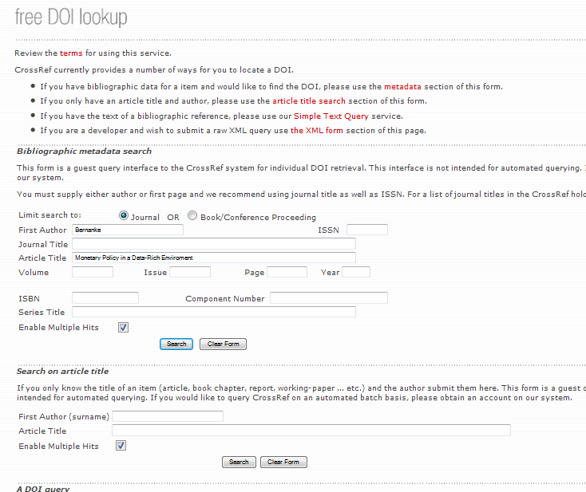

When a given article has the DOI number it should be added in the end in the bibliography. The print screen of the DOI website with the article with DOI number is available below.

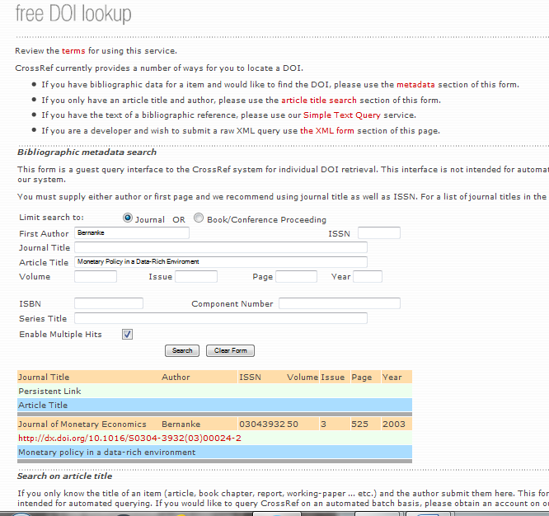

When one copy DOI from the original article or from the above system – delete “http://dx.doi.org/”. The example of the articles with DOI in the References are presented below:

Bernanke, B., & Boivin, J. (2010). Monetary policy in a data-rich enviroment. Journal of Monetary Economics, 50(3), 25–38. https://doi.org/10.1016/S0304-3932(03)00024-2.

Poon, S. H., & Granger, C. (2003). Forecasting volatility in financial markets: a review. Journal of Economic Literature, 19(1), 25–38. https://doi.org/10.1257/002205762743.

Example of the section references:

References (Cambia, 10 pt, bold, left justified)

Baro, K. (2000). Microeconomics. New York: New York University Press.
Bernanke, B., & Boivin, J. (2010). Monetary policy in a data-rich environment. Journal of Monetary Economics, 50(3), 25–38. https://doi.org/10.1016/S0304-3932(03)00024-2.
Hendry, D. F. (2000). Econometrics: Alchemy or science? Oxford: Oxford University Press.
Mizon, G. E. (1995). Progressive modelling of macroeconomic time series: The LSE methodology. In K. D. Hoover (Ed.). Macroeconomics: developments, tensions and prospects (pp. 25–38). Dordrecht: Kluver Academic Press.
Mizon, G. E. (1998). Progressive modelling of macroeconomic time series: The LSE methodology. In K. D. Hoover & G. Mizon (Eds.). Macroeconomics (pp. 25–38). Dordrecht: Kluver Academic Press.
Nelson, C. R., Plosser, C. I., & Granger, C. (1982). Trends and random walks in macroeconomic time series: some evidence and implications. Journal of Monetary Economics, 10(3), 25–38.
Poon, S. H., & Granger, C. (2003). Forecasting volatility in financial markets: A review. Journal of Economic Literature, 19(1), 25–38. https://doi.org/10.1016/S0304-3932(03)00024-2.
Rybiński, A. (2009). Forecasting volatility in financial markets. Retrieved form http://www.rybinski.eu/?p=716& (19.04.2009).

The checklist:
- The bibliography includes more than 20 scientific references.
- The bibliography includes at least 15 references indexed in Web of Science/SCOPUS.
- All the references are written in English.
- All the references must be up to the APA style and DOI system.
- In the list of bibliography positions only the first word of the titles is written with capital letter.

Acknowledgments

This section should provide acknowledgments and information on the financing of the research presented in the article.

Annex

There must be direct references to all tables and figures in the body of the article.

All tables and figures should be placed in the annex in the end of the article.

Tables and figures cannot go out beyond text area!

The article uses (especially in Tables and Figures) the English metric system, so 1.00 is correct (1,00 is incorrect) for decimal numbers!

Specific tables and figures formatting criteria:

    - Figures and tables should be numbered using Arabic numeration 1, 2, 3,… for example: Table 1. Name (description) of the table, Figure 1. Name (description) of the figure (Times New Roman, 10 pt, fully justified).
    - Description of tables and figures should be placed above table and figure. A source or information “the study based on” should be placed under table and drawing, for examples:
    - Tables and figures together with a title and a source should be inside a text column.
    - Figures, graphs or charts should be prepared in MS Excel with attached original file with editing possibility.

Table 1. Name (description) (Times New Roman, bold – Table and number, the tile of the table normal without bold, 10 pt., fully justified)

Text of table (Times New Roman, 8 pt, fully justified, single-space line)

Source: Hilbers et al. (2005), Kowalski (2008, p. 53). (Times New Roman, 9 pt, left justified)

Figure 1. Structure of households expenditures in Poland in years 1993-2005 (share of expenditures in %) (Times New Roman, bold – Table and number, the tile of the table normal without bold, 10 pt, fully justified)

Source: own calculations based on OECD (2007, pp. 94-98), Eurostat (2009). (Times New Roman, 9)

